FLB | FINANCIAL LAW BOARD

QUADRILATERAL MEETING OF THE
EFMLG/FMLC/FMLG/FLB
AGENDA

Thursday 11 – Friday 12 July 2019

Seminar Room
Anderson Mori & Tomotsune
1-1-1 Otemachi, Chiyoda-ku,
Tokyo 100-8136, Japan

* Social Events (Optional) at the Bank of Japan
on Wednesday 10 July 2019

Wednesday 10 July 2019 – Social Events (Optional)
13:30 – 15:30 | Tour of Bank of Japan’s Head Office and Currency Museum (Where we meet: East Entrance)  ✔ Please allow sufficient time for the security check before you will be allowed to the Bank of Japan building. The participant will need their ID card such as passport, driver's license, employee photo ID.  ✔ Tour of Bank of Japan’s Head Office includes a walk outside to look around the buildings registered as an Important Cultural Property, and chance to take pictures with replicas of a 100-million-yen banknote package and a gold bar. The Currency Museum of the Bank of Japan’s Institute for Monetary and Economic Studies collects, preserves, and studies currency and currency-related historical and cultural materials.
Bank of Japan
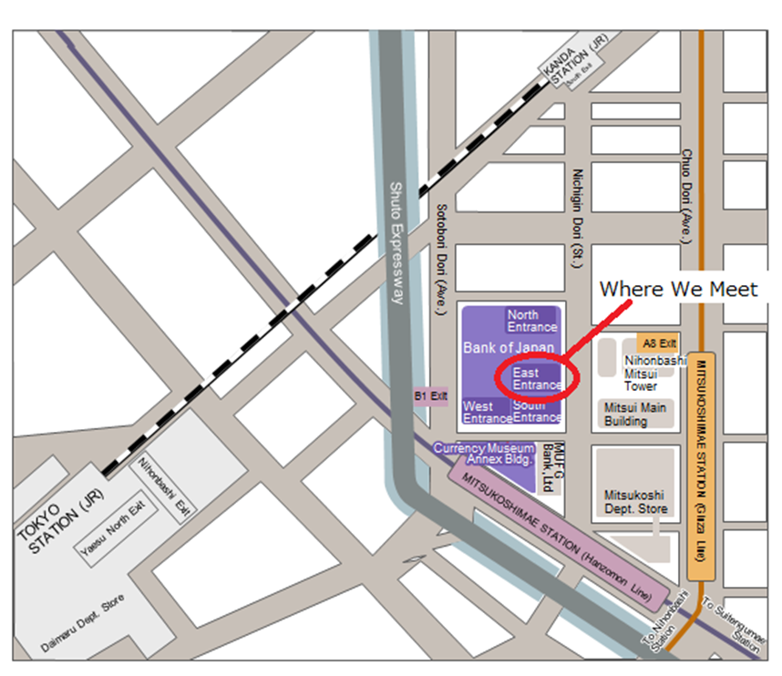

Thursday 11 July 2019 – Conference Day 1
13:00 – 13:30 |  | Registration
13:30 – 13:35 |  | Opening / Introduction (Kunihiko Morishita(FLB) )
13:35 – 13:55 |  | Cluster 1: FLB’s History and Role (including Functions and Organization of Bank of Japan (Kunihiko Morishita / Makoto Chiba (FLB)) (20 min)
14:00 – 15:00 |  | Cluster 2: Brexit – in brief (Chair: Lord Thomas (FMLC))
 | 14:00 – 14:20 | Section 1: [Brief Overview of the current situation and a summary of potential financial regulatory issues] – Joanna Perkins (FMLC) (20 min)
 | 14:20 – 14:35 | Section 2: Brexit from EU perspective – Inigo Arruga Oleaga (EFMLG) (15 min)
 | 14:35 – 14:50 | Section 3: Settlement Finality Directive (“SFD”) and third country systems – David Trapani (FMLG) (15 min)
 | 14:50 – 15:00 | Discussions
15:00 – 15:15 |  | Special Remarks (Speaker: Lord Thomas – Experience of serving as the Lord Chief Justice of England and Wales)
15:15 – 15:55 |  | Coffee Break (Guest Speaker: David Hewett)
15:55 – 17:25 |  | Cluster 3: Interest Rate Benchmark Reform (Chair: Akihiro Wani)
 | 15:55 – 16:15 | Section 1: LIBOR: reference rate solutions, contractual challenges and mitigants – Kate Gibbons / Barney Reynolds (FMLC) (20 min)
 | 16:15 – 16:35 | Section 2: U.S. benchmark reform – Tom Noone (FMLG) (20 min)
 | 16:35 – 16:55 | Section 3: Interaction between EU Benchmark Regulation, third country benchmarks and third country regulations –Virginie Duval (EFMLG) (20 min)
 | 16:55 – 17:15 | Section 4: Interest rate reform in Japan – Akihiro Wani / Yosuke Unami (FLB) (20 min)
 | 17:15 – 17:25 | Discussions
17:30 – 18:00 |  | Keynote Address (Speaker: Hiroshi Nakaso (Chairman of the Institute, Daiwa Institute of Research Ltd.) – “Is the world safe? A decade after GFC”)
18:15 – 18:45 |  | Move to Ukai (by charter bus)
19:00 – 22:00 |  | Dinner at Ukai

Friday 12 July 2019 – Conference Day 2
09:30 – 10:00 |  | Registration
10:00 – 11:20 |  | Cluster 4: Recent Regulatory Trends in Japan – in the context of global harmonization (Chair: Kunihiko Morishita (FLB))
 | 10:00 – 10:25 | Section 1: Recent Regulatory Developments in Japan – Hideki Kanda (FLB) (25 min)
 | 10:25 – 10:50 | Section 2: Addressing Market Fragmentation – Satoshi Izumihara / Tomoaki Hayashi (both Deputy Director, Office of International Affairs of the FSA, Japan) (guest speakers) (25 min)
 | 10:50 – 11:10 | Section 3: The extraterritorial effect of EU regulation and its impact on cross-border transactions – Holger Hartenfels (EFMLG) (20 min)
 | 11:10 – 11:20 | Discussions
11:20 –12:45 |  | Cluster 5: Margin Rules and Other Industry Issues (Chair: Michael Nelson)
 | 11:20 – 11:35 | Section 1: Sustainable Finance in the EU: latest progress – Inigo Arruga Oleaga (EFMLG) (15 min)
 | 11:35 – 11:50 | Section 2: Global Margin Developments – Carolyn Jackson (FMLC) (15 min)
 | 11:50 – 12:05 | Section 3: Uncleared Derivatives Initial Margin: Client Challenges for 2020 – Greg Todd (FMLG) (15 min)
 | 12:05 – 12:20 | Section 4: Recent FCA Recognition of Two Industry Codes – Habib Motani (FMLC) (15 min)
 | 12:20 – 12:35 | Section 5: Industry Codes – An Evolution – Nancy Rigby / Frank Weigand (FMLG) (15 min)
 | 12:35 – 12:45 | Discussions
12:45 – 13:30 |  | Lunch Break
13:30 – 14:35 |  | Cluster 6: Fintech (Chair: Otto Heinz)
 | 13:30 – 13:45 | Section 1: A U.S. perspective on the regulatory approach to digital assets – Bob Klein / Terence Filewych (FMLG) (15 min)
 | 13:45 – 14:00 | Section 2: Fintech: The new regulatory architecture of MLD5 – Joanna Perkins (FMLC) (15 min)
 | 14:00 – 14:15 | Section 3: Cryptoassets and the UK regulatory perimeter – Michael Sholem (FMLC) (15 min)
 | 14:15 – 14:30 | Section 4: Fintech: Recent developments in Japan – Ken Kawai (FLB) (15 min)
 | 14:30 – 14:40 | Discussions

14:40 – 14:45 |  | Closing Remarks (Kunihiko Morishita (FLB))

Anderson Mori & Tomotsune
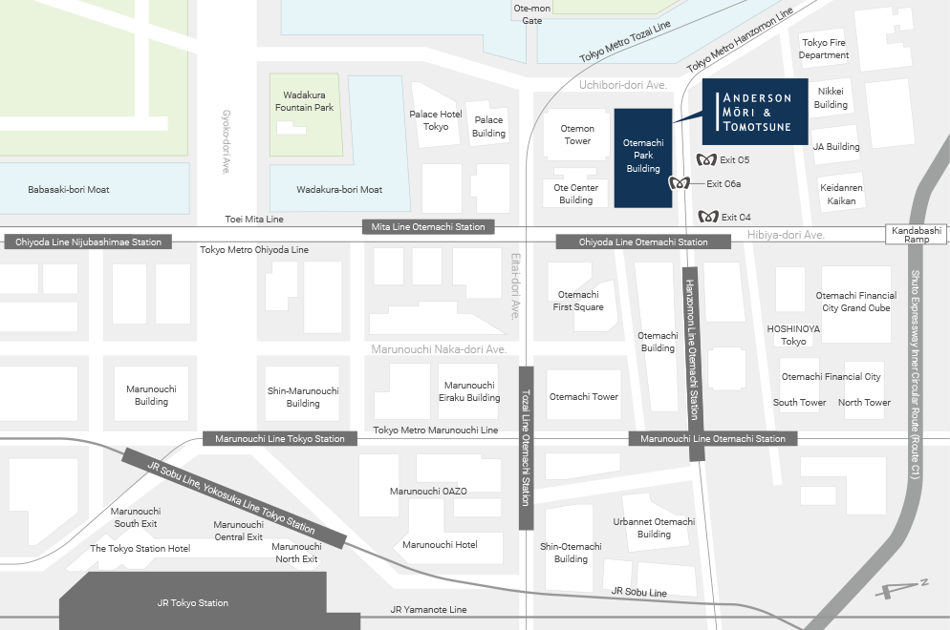
Ukai (Dinner)
